**School of Information and Communication Technology**

**Griffith University**

**3821ICT**

**Intelligent Restaurant Engagement Platform**

**Team Organisation**

*Date of Submission (Include Year and Trimester)*

**Industry Partner: Vision Verse Interactive**

**Client: Zita Wong**

**Team members:**

Amare Biyabeyin

Andy Chen

Eve Buckton

Harvey Shaw

Liam Preston



**Revision History**

| **Date** | **Version** | **Author(s)** | **Comments** |
| --- | --- | --- | --- |
| 29/07/2024 | 0.1 | Harvey Shaw | Initializing Document, adding basic details |
|  |  |  |  |
|  |  |  |  |
|  |  |  |  |
|  |  |  |  |

*This template is intended to be a guide for developing the team organisation document. Items that are intended to stay in as part of your document are numbered headings; italic red text is used for explanatory information that should be removed when the template is used.*

**Table of Contents**

**1.** **ORGANISATIONAL STRUCTURE 4**

**2.** **PROJECT RESPONSIBILITIES 4**

**3.** **COMMUNICATION 4**

**3.1.** **Communication Channels 4**

**3.2.** **Decision Making 4**

**3.3.** **Conflict Management 4**

**3.4.** **Task/Progress Management 4**

**4.** **SKILL NEEDS 4**

**4.1.** **Identification of Skill Needs 4**

**4.2.** **Satisfaction of Skill Needs 4**

**5.** **SUCCESS CRITERIA 5**

**6.** **STANDARDS FOR WORK PRODUCTS 5**

**7.** **RISK MANAGEMENT 5**

**8.** **CHANGE CONTROL MANAGEMENT 5**

**9.** **AGREEMENTS 5**

# **ORGANISATIONAL STRUCTURE**

## *How have you organised your team, and how does it relate to external groups? Add a diagram and discuss the diagram in more detail.*

# **PROJECT RESPONSIBILITIES**

Amare Biyabeyin: Chief Designer, Programmer

Andy Chen: Testing Manager

Eve Buckton: Quality Manager, Configuration Manager

Harvey Shaw: Project Manager, Client Liaison

Liam Preston: Requirements Manager, Assessor Liaison

Note: Since this project will require a diverse set of programming skills everyone will do some programming

## *List the roles needed for your project, the responsibilities for that role, and the person assigned to the role. This should be clearly defined and be consistent with your product needs.*

*List the expected professional behaviour and team conduct you expect from everyone as a team and from each team member based on their role.*

# **COMMUNICATION**

## **Communication Channels**

Teams

*How will your team communicate with one another? How will you organise and conduct your team meetings? How will you ask questions to other team members?*

## **Decision Making**

Majority rules

*How will you make decisions in your team? Will the majority rule or will the lead developer make the final decision with regards to software development, or will the project manager make the final decision?*

## **Conflict Management**

* 1. Difference of opinion:

Compromise

* 1. Lack of Contribution:

Contact the team member to find the problem

Offer assistance

Contact course convenor

3.6 Unprofessional behaviour:

Confront the team member

Contact course conver

*How will you make deal with conflict or a difference of opinion in your team? How will you you deal with a situation where a team member does not contribute or deliver work of poor quality? How will you deal with unprofessional behaviour of a team member?*

## **Task/Progress Management**

One by one go through each of our progress. The project manager will go through the kanban b

*How will you do your stand-ups/report your progress? How will the project manager track the progress of the team? How will you manage as a team a situation where team member(s) do not deliver on their tasks on time, and this may cause you to miss the assessment deadline or not finish everything by the assessment deadline?*

# **SKILL NEEDS**

## **Identification of Skill Needs**

*Give a full list of skills needed for this project.*

## **Satisfaction of Skill Needs**

*How well does your team meet the skill needs for the project? Use a skills matrix. How will you deal with any unmet skill needs?*

# **SUCCESS CRITERIA**

*List your success criteria for the project and the team – what do you need to achieve in order to consider your project a success? These should be prioritised, measurable and testable, because you’ll be reviewing your project against these criteria at the end.*

# **STANDARDS FOR WORK PRODUCTS**

*Include the internal documentation standard your team is using, as well as any other relevant standards you are following for each stage of the process (i.e. design, coding and testing standards – there are ISO standards, industry standards or possibly client standards available). How will you ensure that you have followed the standards?*

# **RISK MANAGEMENT**

*This should present a risk matrix. This should cover identification of the risk factors and potential ethical issues associated with this project; assessment of the possible impact; clear description of management strategies for avoiding, containing and recovery from risk and potential negative outcomes. This section should relate specifically and practically to this project; it should* ***not*** *be a theoretical description of how risk management is undertaken.*

# **CHANGE CONTROL MANAGEMENT**

*This should outline the procedures or processes you will use for tracking and controlling the various items that may be changed or updated throughout the project. This might be changes to deliverables, development code, application revisions.*

# **AGREEMENTS**

All persons identified in this document sign the form below to indicate that they have read the Team Organisation and Agreement and agree to the contents therein.

Team member 1 Name 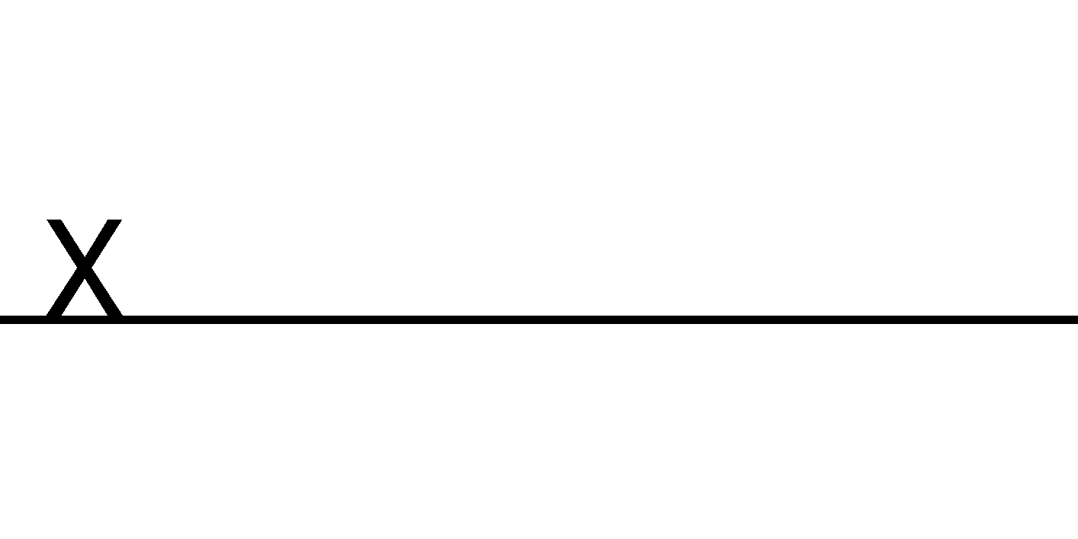

Team member 2 Name 

Team member 3 Name 

Team member 4 Name 

Team member 5 Name 

Team member 6 Name 